**SCORM Export Settings**

**Please identify the below setting choices (LMS tech specs) before we can export and send a SCORM file of your course.**

***\*\*\*Please note: Without proper setting selections on the client’s part, the SCORM sent by the vendor will not be compatible with your LMS. The SCORM package will simply ‘crash’. \*\*\****

***These settings can only be properly set by the sender before sending over the file. Once the file is received, these settings can no longer be manually altered on your end. If settings are incorrect, new packages will need to be resent*** *(costs may occur)****.***

Your LMS team can assist with these familiar selection choices. The below **screenshots** can provide you with a visual map of the settings our team will manually set for your package in accordance with your selections to ensure compatibility.

**Please fill in the following details starting on page 2: (There are 3 sections to fill out)**

**Export Type:**

Please note, our course can only be exported as an LMS format. (*in a SCORM package*)   
  
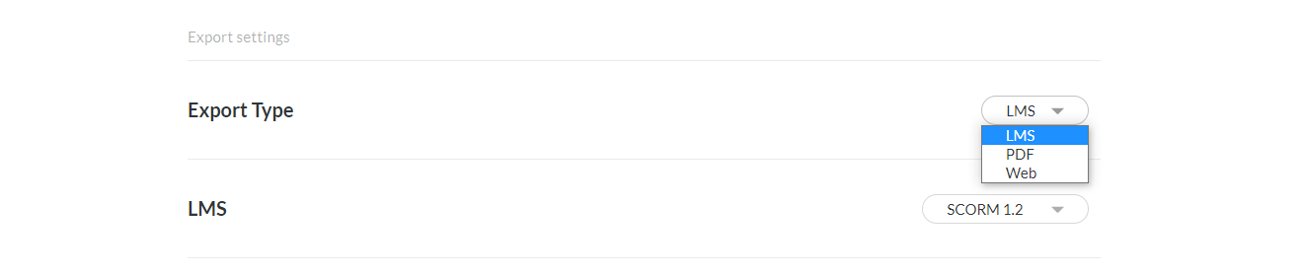

**PLEASE SELECT THE BELOW:**

**#1 Your LMS setting is:**

| **Fill in your selection here: ___________**  **Fill in your selection of edition here: ___________ (IF SCORM 2004)** |
| --- |

You have a choice of SCORM **1.2**

*or*

SCORM **2004** (please specify which edition: 2nd, 3rd, or 4th edition)

Please note: *we do* ***not*** *offer AICC, xAPI/TinCan, or cmi5 editions of the course as we cannot guarantee functionality or offer support for these file types. This course was designed to be delivered in SCORM only.*

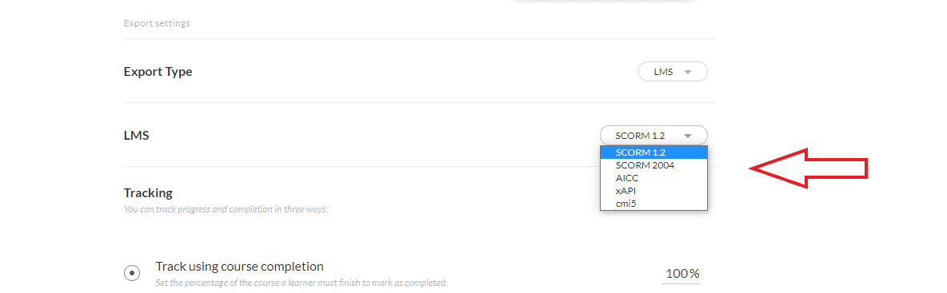

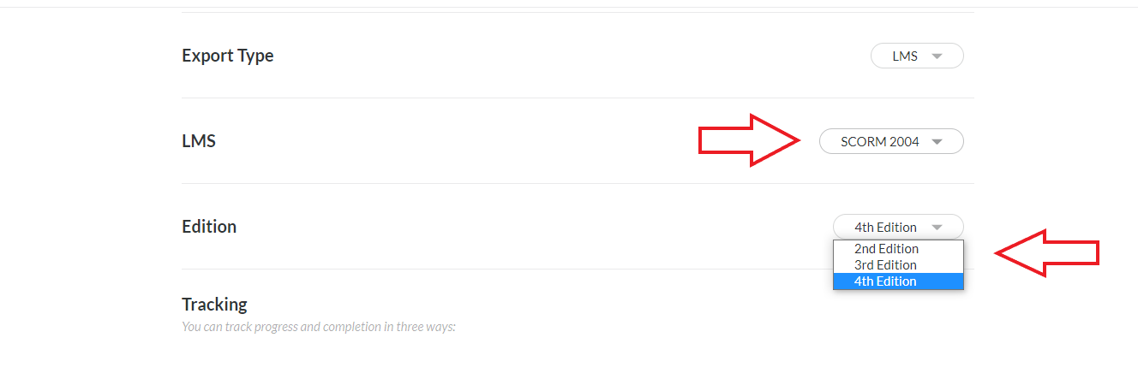

**#2 Tracking:** Our course includes a final quiz which tests the learner’s comprehension and unlocks access to a certificate of completion in the following lesson.

For this reason, **our standard course tracks via quiz success and our default reporting is set to Passed/Incomplete. This can be changed based on your selection.**

| **Fill in your selection here: ___________** |
| --- |

**If selecting the ‘track using course completion = 100%’,** the reporting has 2 options below to select from: Passed/Incomplete OR Complete/Incomplete

| **(If applicable) Fill in your selection here: ___________**  *(Passed/Incomplete* ***or*** *Complete/Incomplete)* |
| --- |

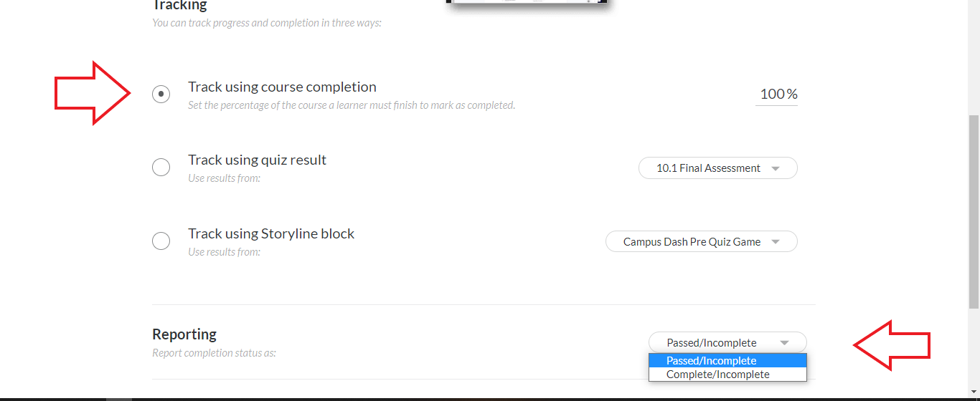

**If selecting the tracking via Quiz**, the reporting has 4 options: Passed/Incomplete or Passed/Failed or Complete/Incomplete or Complete/Failed

| **(If applicable) Fill in your selection here: ___________**  *(Passed/Incomplete or Passed/Failed or Complete/Incomplete or Complete/Failed)* |
| --- |

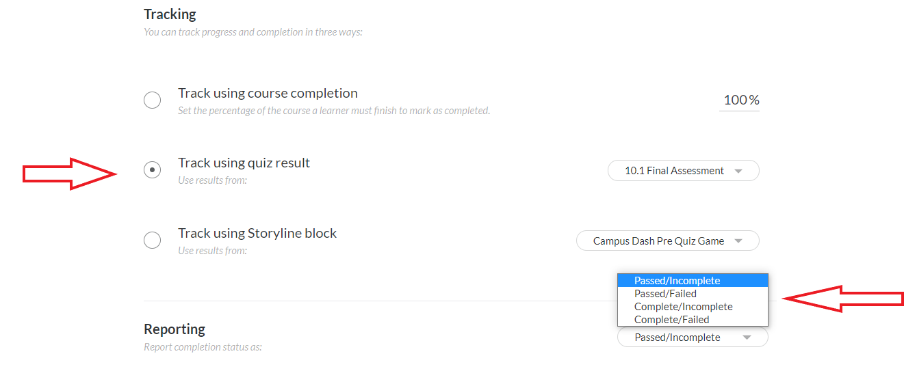

**#3 Quiz Settings in the final chapter 10:**

Please note: *Our course has by default a 65% passing score with an ‘enabled Passing score to continue’. Quiz Retries are set to unlimited.*

*We offer choices for your organization’s preference, based on your own learning and assessing the environment for your employees. Does your organization have a pre-determined passing percentage?* ***Our course’s quiz settings can be adjusted to your preferences****. Please select from the below your % selection:*

| **Fill in your selection here: ___________** |
| --- |

